بسم الله الرحمن الرحيم
The name: sara mohammed.
The project name : CD_player.
The source of project: The code project.
The brief description for the project:
The program is an example for playing audio but it plays audio from the cdRom or another device such it.

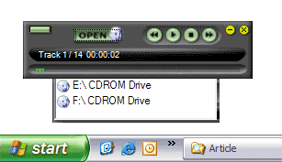

-It strats with open the CDRom and playing it as tracks not as files. -We can choose a specific track by moving them .
-At the end of each track we can know the time that it takes and the number of it. -The program show the number of tracks on the CD.
-If the CDRom hasn't CD or has anon audio CD the program give an error message.

